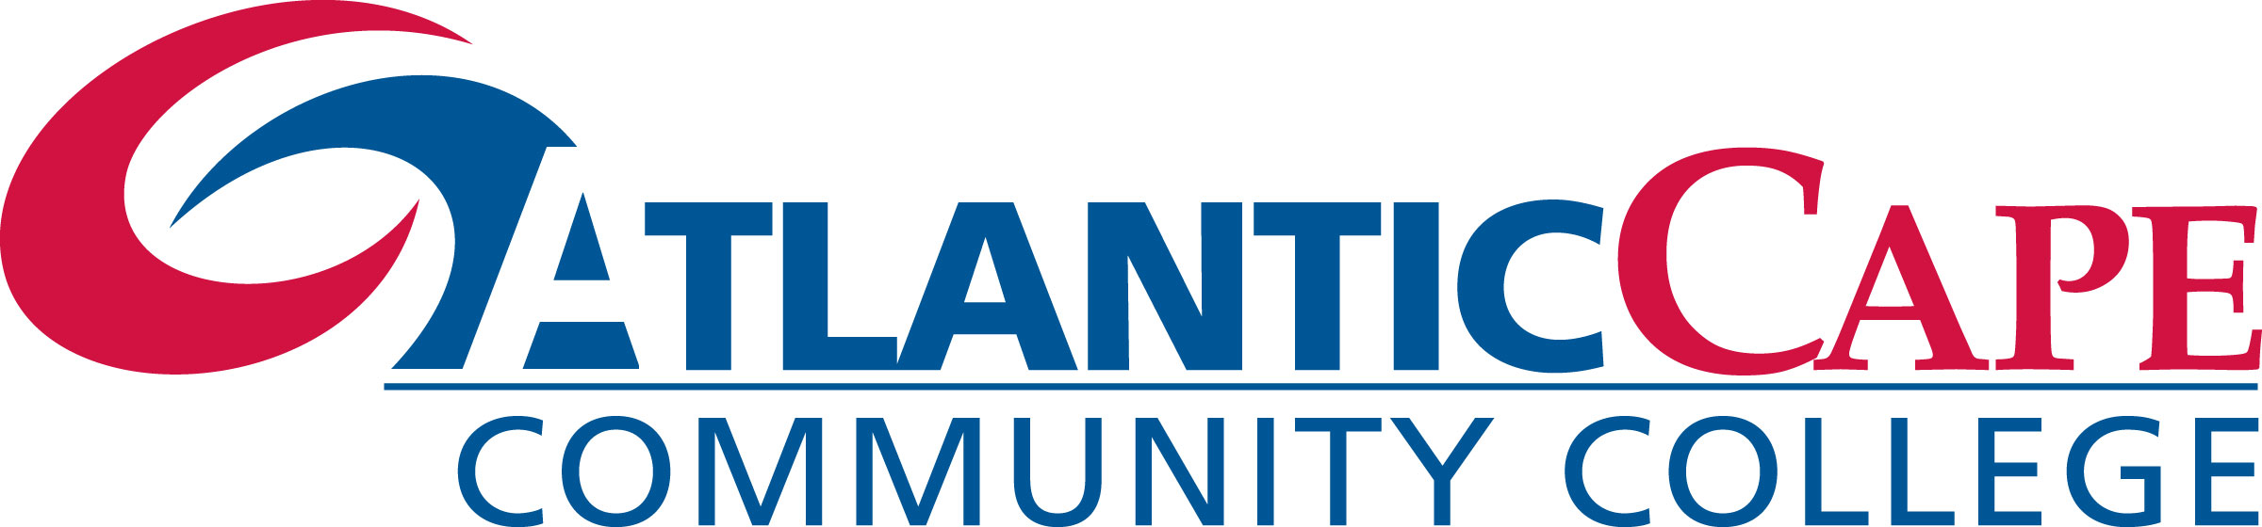

We are happy to announce the continued partnership between

Egg Harbor Township High School and Atlantic Cape Community College

to offer the Math Accelerated Learning Program.

Eligible students will be offered college level courses at no cost, tuition, books, fees, etc. included. Details are as follows:

Math Boot Camp (MATH 073 OR MATH074)
This program allows eligible students to complete the equivalent 15 week semester college remediation math course in just 7 days. Successful completion of this program allows students to move up one level in college math, saving time and money and allowing quicker advancement toward a degree.
- The program will be computer-assisted, individually designed & guided, allowing students to work at their own pace
- This program is totally FREE of any fees for eligible students
- Math Boot Camp runs Monday & Wednesday, May 1 – May 22, 2019 from 2:15-5:15pm at Egg Harbor Township High School.
PARENT-STUDENT MEETING
DATE: TUESDAY, APRIL 16, 2019
TIME: 6:00PM LOCATION: F106
----------------------------------------------------------------------------------------------------------------
COMPLETE THIS PORTION AND RETURN TO GUIDANCE

STUDENT NAME (PRINT): ______________________________________
I intend to participate in the Math Boot Camp course on Mondays & Wednesdays from May 1 to May 22 at Egg Harbor Township High School.
Student Signature: __________________________________ Date:_____________
Parent/Guardian Signature: ____________________________ Date: _____________
----------------------------------------------------------------------------------------------------------------

“The Accelerated Learning Program Initiative is developed under a grant from the State of New Jersey that is administered by the New Jersey Office of the Secretary of Higher Education (OSHE). However, these contents do not necessarily represent the policy of the State of New Jersey or the OSHE, and you should not assume endorsement by State Government.”

