Register for FREE

2018 ANNUAL FALL SAT/ACT PREP
Three Day Boot Camp
9th – 12th Grade
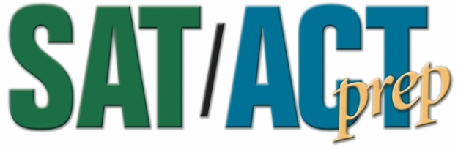

CONNECTING THE DOTS INC.
“The Scholarship Lady U.S.” Carla Dickerson and Staff
November 13, 14, 15, 2018
Atlantic Cape Community College, Worthington Campus
1535 Bacharach Blvd Atlantic City NJ 08401
Snack 4:30-5:00 (Cafeteria only)
SAT/ACT Prep Class 5:00PM – 8:30PM
Contact: Connecting The Dots Inc.609-705-2454, cell 609-705-4016
ctdadvancingtocollege@gmail.com

Students must attend all three days / bring Scientific SAT/ACT Calculator for Math
Three Day Event includes:
SAT-ACT test enrichment
- Critical Reading
- Planning and writing different types of essays
- Math Strategies and Tips
- Test Taking Tips

Limited space available

